Daily Sketch

Draw the image below trying to capture all the contour lines and shadows.

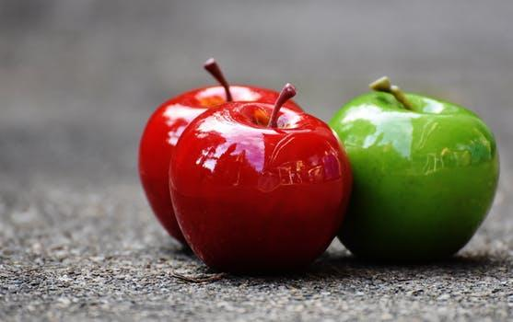

Still life- A still life is a work of art depicting mostly inanimate subject matter, typically commonplace objects which are either natural or man-made.

Contour- Lines around an object

Cross contour- They are the lines that reflect the movement of your eye in and around what you see.While contour lines describe edges, cross-contours describe form and volume.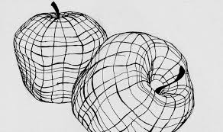

Cross Hatching- Hatching is an artistic technique used to create tonal or shading effects by drawing closely spaced parallel lines. When lines are placed at an angle to one another. Lines criss cross each other.

Hatching- is an artistic technique used to create tonal or shading effects by drawing (or painting or scribing) closely spaced parallel lines. Lines all go in one direction

